**1. Bipartite Graph:**

A graph G = (V, E) is bipartite if and only if its vertex set V can be partitioned into two non-empty subsets X and Y, such that every edge in E has one endpoint in X and the other endpoint in Y. This partition of vertices is also known as bi-partition.

**Example of Bipartite Graph**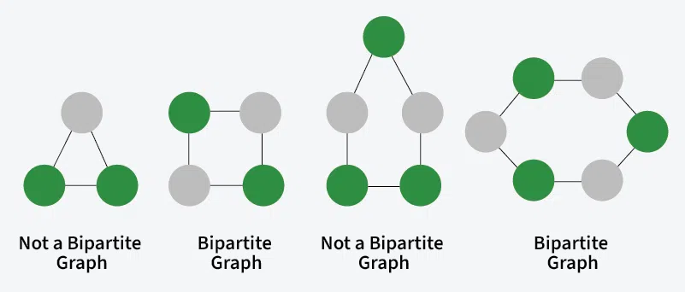

Note: In the above image nodes of the same colour belong to the same set.

**How to identify Bipartite Graph?**

* Choose any vertex in the graph and assign it to one of the two sets, say X.
* Assign all of its neighbors to the other set, say Y.
* For each vertex in set Y, assign all their unassigned neighbors to set X, and for each vertex in set X, assign all their unassigned neighbors to set Y.
* Check if any two adjacent vertices are in the same set. If yes, then the graph is not bipartite. Otherwise, it is bipartite.

**2. Sparse Graph:** A sparse graph is a type of graph in which the number of edges is significantly less than the maximum number of possible edges. In other words, only a few nodes (or vertices) are connected to each other compared to the total number of connections that could exist.

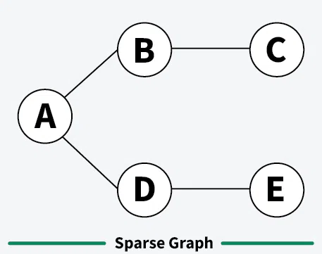

**3. Dense Graph:** A dense graph is a type of graph where the number of edges is close to the maximum number of possible edges. In simple terms, most of the vertices are connected to each other and leading to a high level of connectivity.

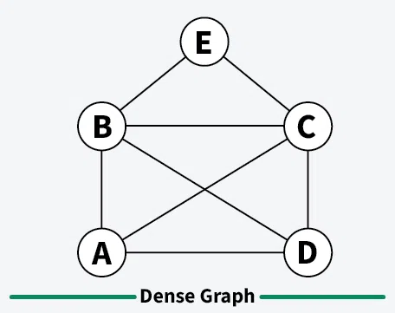

**4. Finite Graph:** A graph is said to be finite if it has a finite number of vertices and a finite number of edges.

**5. Infinite Graph:** A graph is said to be infinite if it has an infinite number of vertices as well as an infinite number of edges.

**6. Pseudo Graph:** A graph G with a self-loop and some multiple edges is called a pseudo graph. A pseudo graph is a type of graph that allows for the existence of self-loops (edges that connect a vertex to itself) and multiple edges (more than one edge connecting two vertices).

